Screenshot01 – Application with Information Inputted into Program

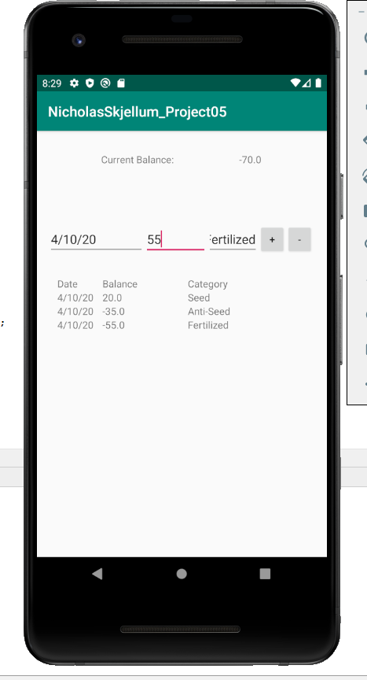

Screenshot02 – Application loaded in new instance, data is preserved.

